Technology Portfolio 2016
Online Profiles
MyUEN.org
http://my.uen.org/myuen/91095
LinkedIn
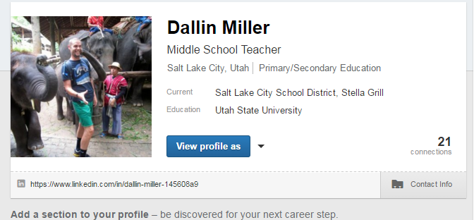

Blog
www.northwestmiddlerocks.com
Library Technology Teacher
Collaborating Lesson Plan: An ELA teacher and prepared a lesson on book reviews. Students created a Publisher document telling readers why they loved their books and who would love them too.
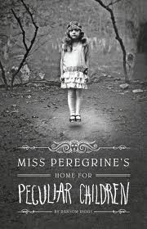
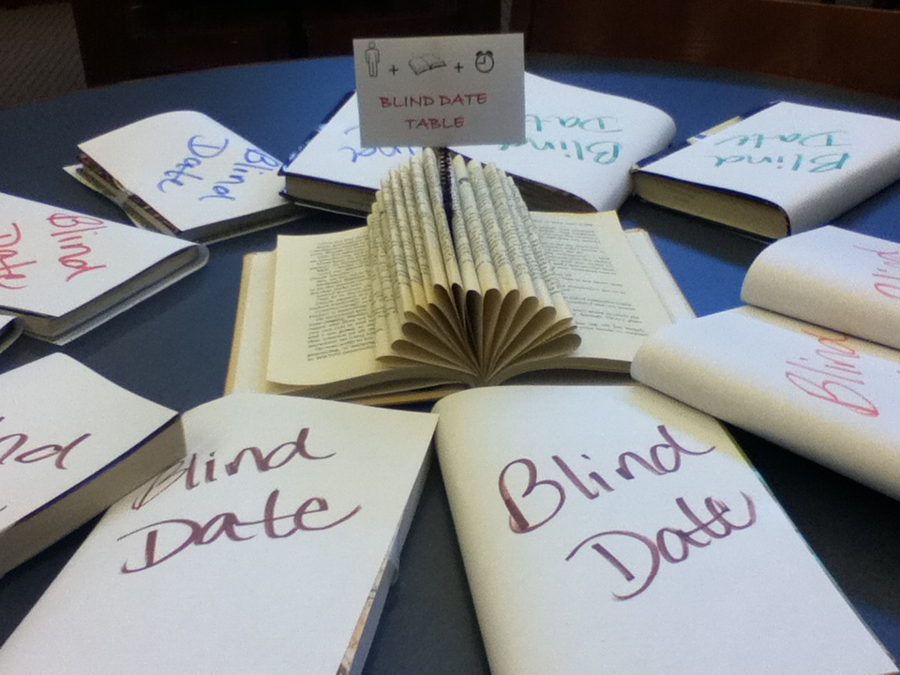
Encourage Students to Read Promotion: Book Club at Lunch! 7th and 8th graders were invited to read the Miss Peregrine series with the librarian. For incentive, students get the book, eat lunch in the library, and a weekly treat. Those 7th graders that finish the book, get to watch the movie next school year.
Lesson Plan: Speed dating: Students complete a 2 minute date with 10-12 books. Student evaluate the book quickly, then decide which books they’d like to read. When finished, add those titles to their catalog.
Professional Learning Community
Monthly Newsletter for the school
NWMS Instagram Account

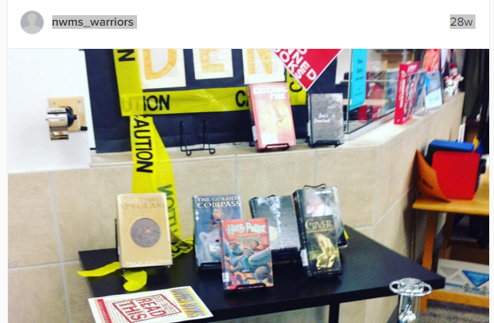

9Blog
http://www.mightylittlelibrarian.com/
Empowering Students
Movie Making
How to Survive Middle School: Students wrote an expository essay on how to survive a certain teacher’s class. Going through the design thinking process, student gained empathy to understand the basic needs a 6th grader needs to be successful in the first year of middle school.
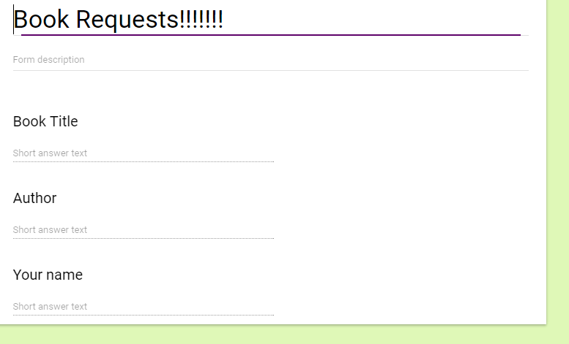
Tech Tips:
Google Add on: lab scheduler
Airserve: Broadcast your iPad with Airplay onto your projector/document camera/Smartboard
Book Requests: Using a google form, students can request books if they can’t find it in the library.
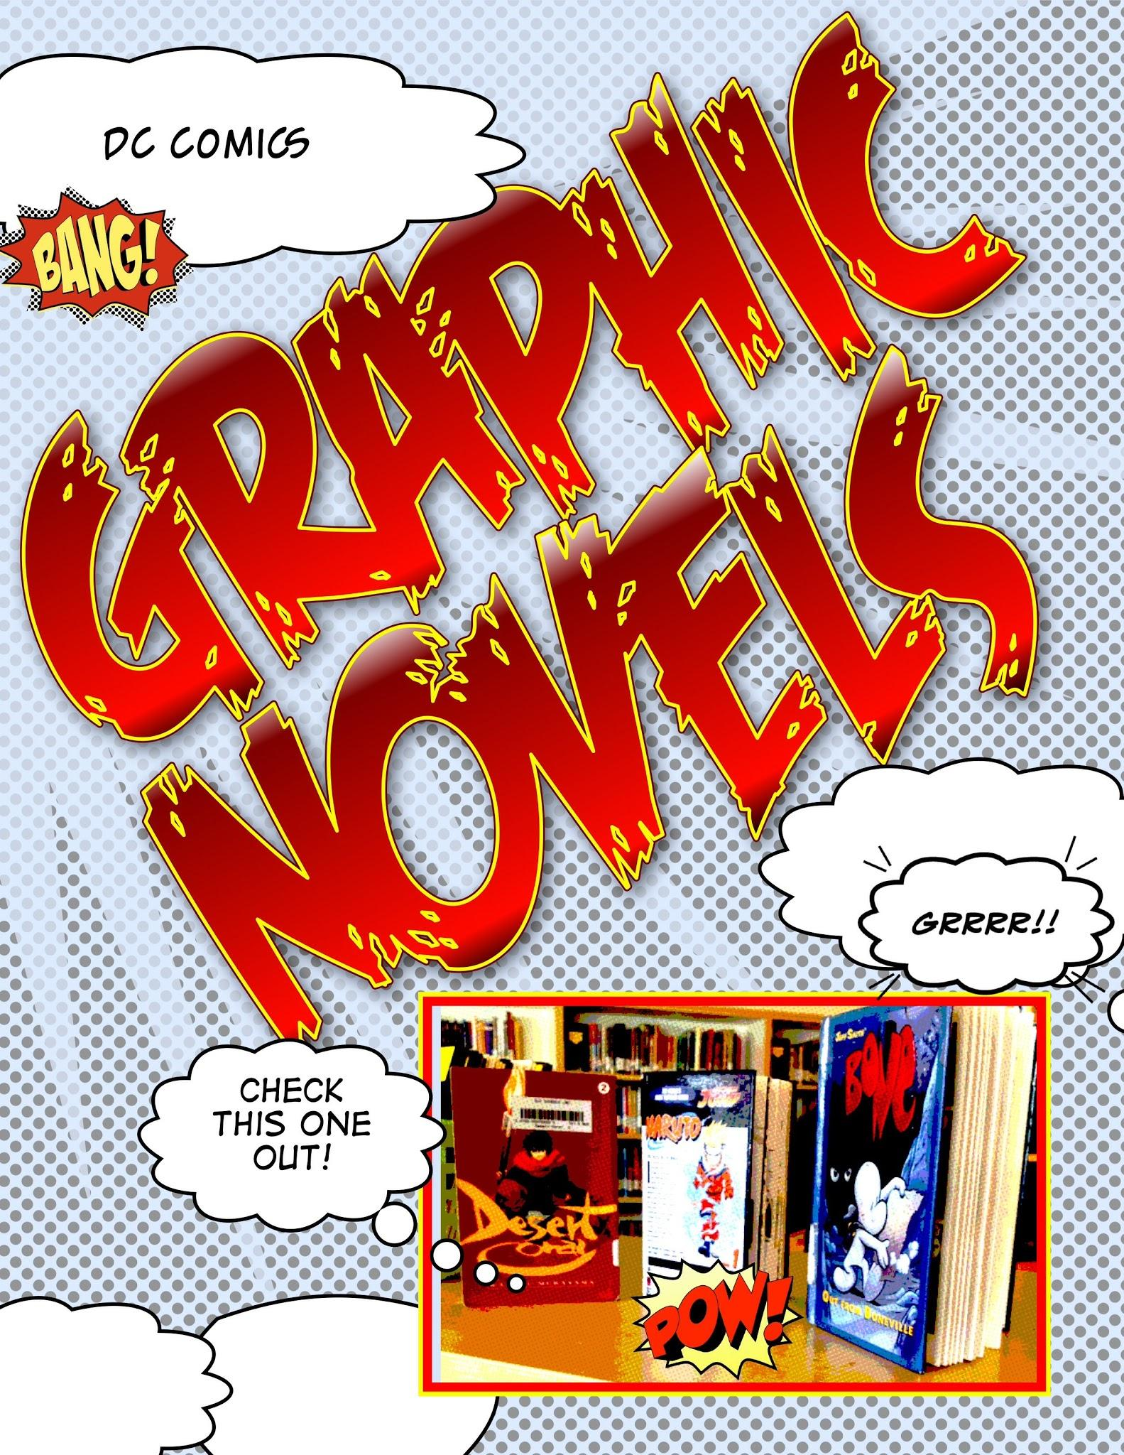
Comic Life
Use comic life to create just about anything. Works best on an iPad!

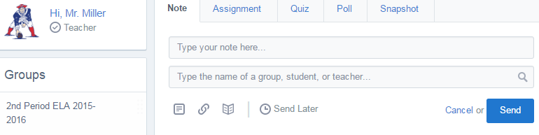
Edmodo

Overdrive

SLCSD is now offering students access to Overdrive to read books on a mobile device. Librarians are trained to help students get a login and have full access to our online library.

